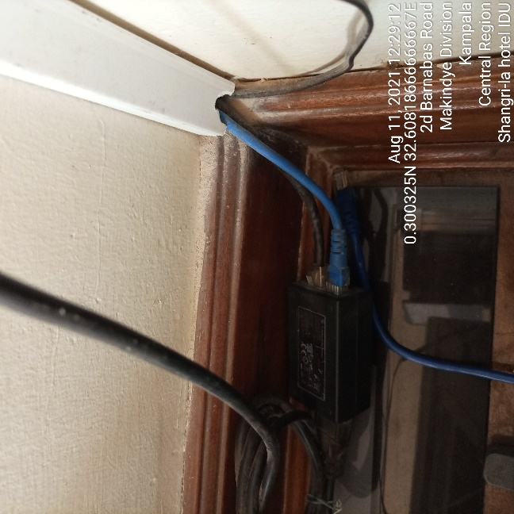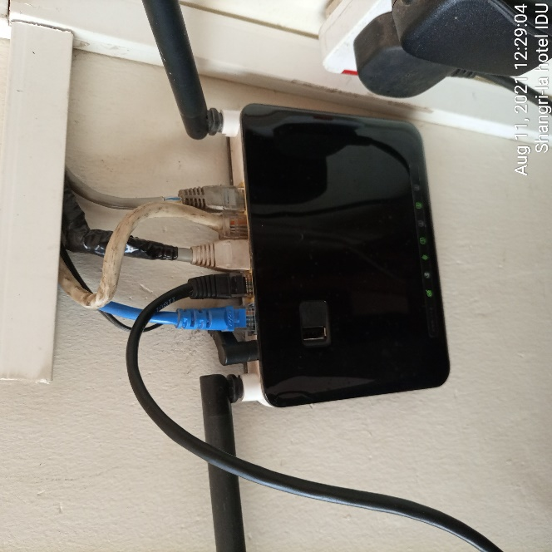
SHANGRI HOTEL IDU SHANGRI HOTEL IDU

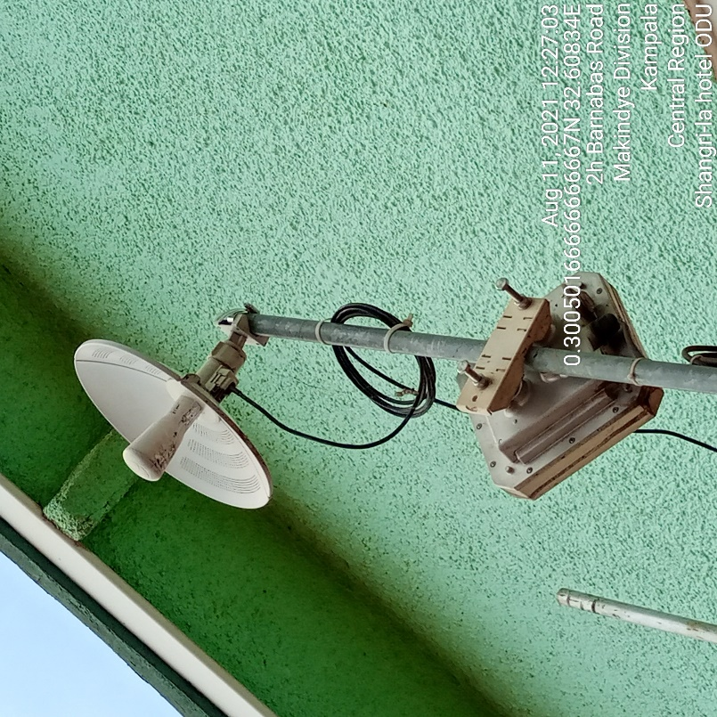
SHANGRI HOTEL ODU

