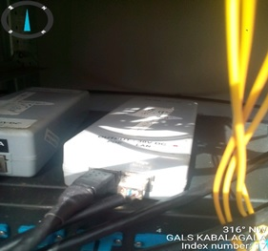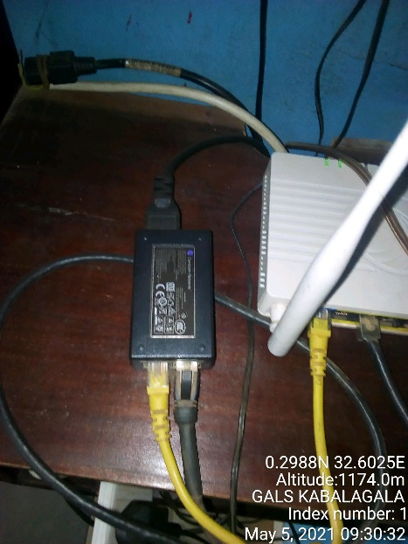
GALS KABALAGALA SITE IDU GALS KABALAGALA IDU
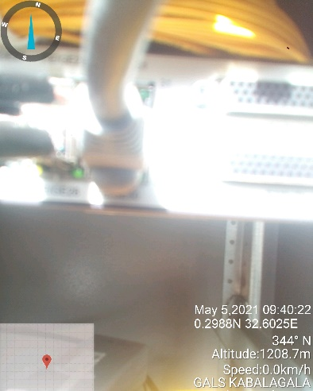
GALS KABALAGALA SITE IDU

