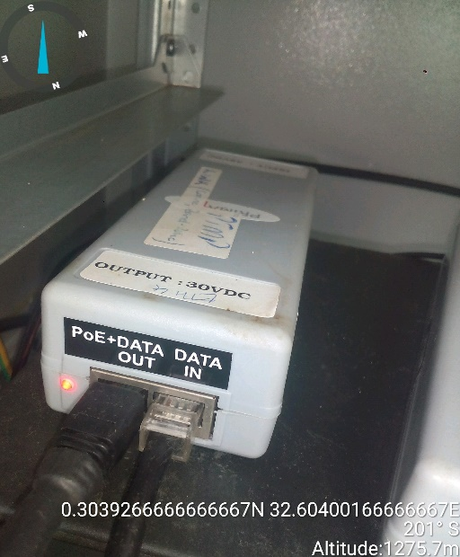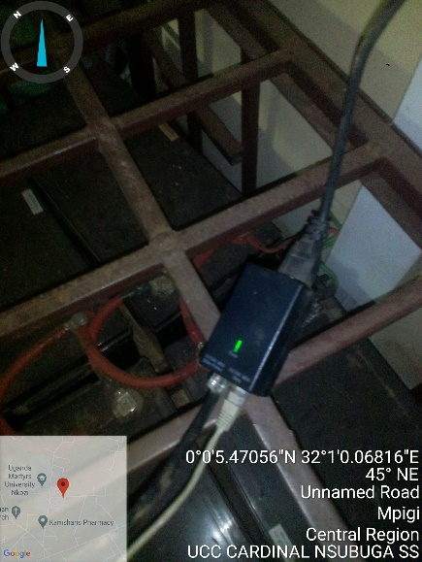
CARDINAL NSUBUGA SITE IDU CARDINAL NSUBUGA IDU
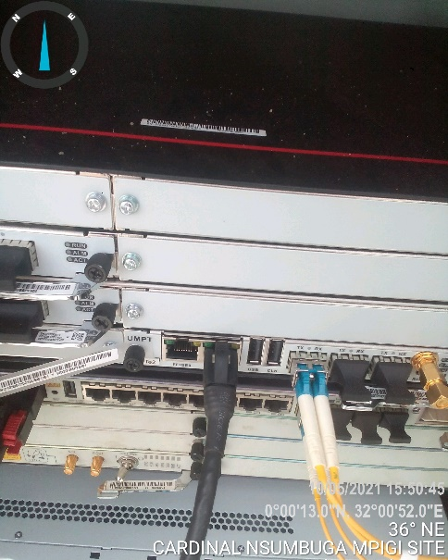
CARDINAL NSUBUGA SITE IDU

