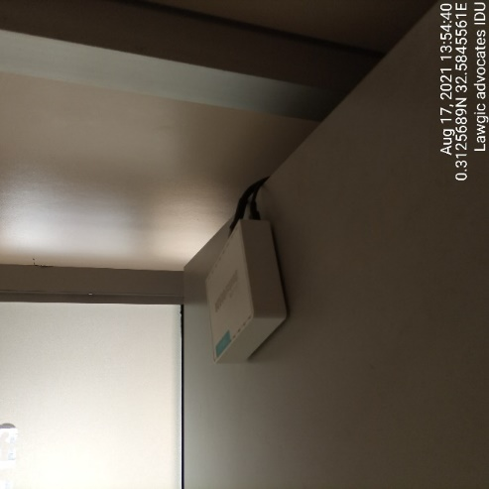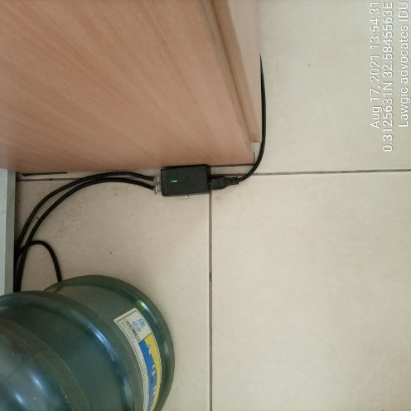
LAWGIC ADVOCATES IDU LAWGIC ADVOCATES IDU
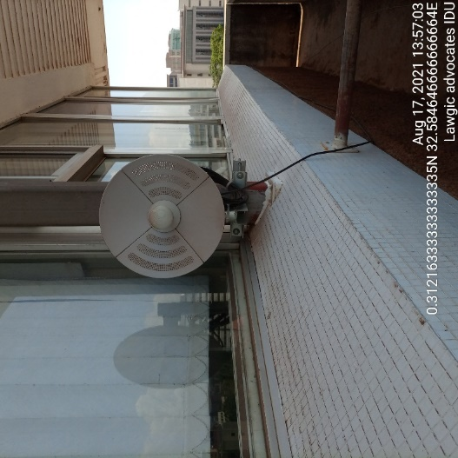
LAWGIC ADVOCATES ODU
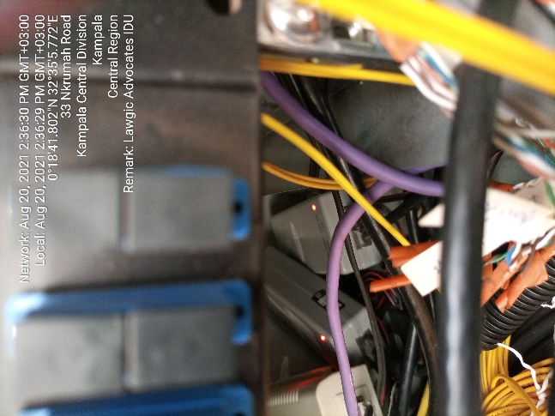
LAWGIC ADVOCATES LAWGIC ADVOCATES

