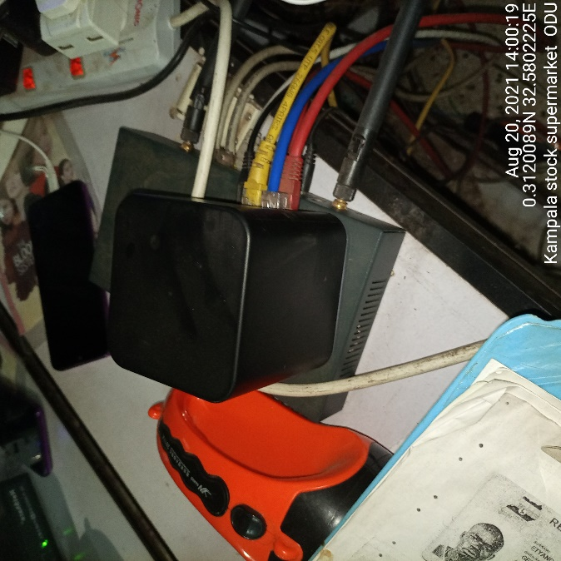
KAMPALA STOCK SUPERMARKET ODU KAMPALA STOC SUPERMARKET IDU
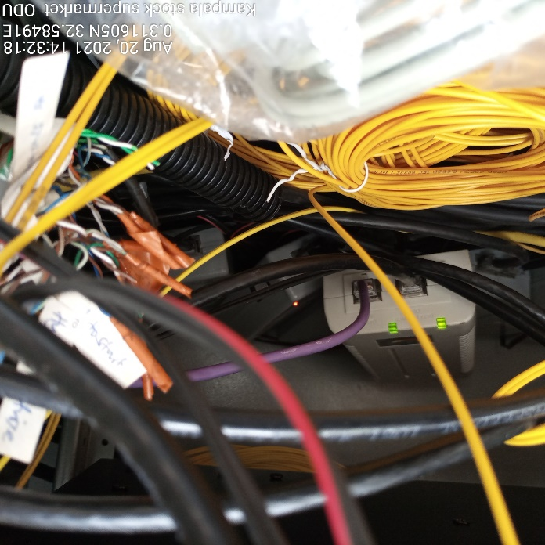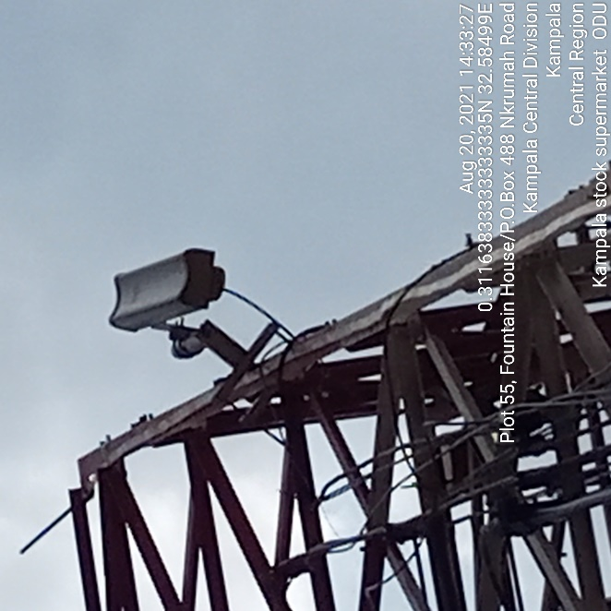
KAMPALA STOCK SUPERMARKET IDU KAMAPALA STOCK SUPERMARKET ODU

