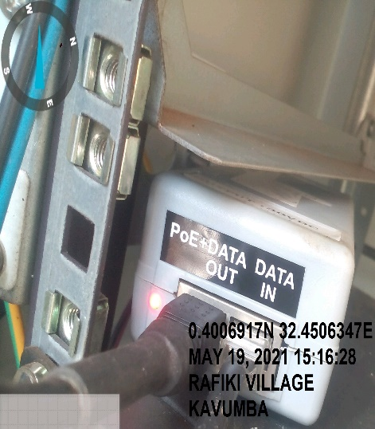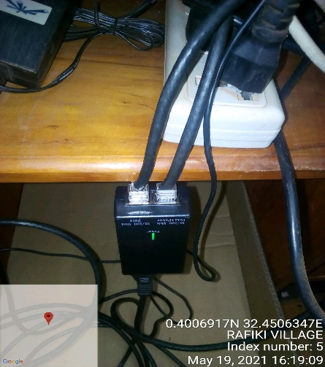
RAFIKI VILLAGE SITE IDU RAFIKI VILLAGE IDU
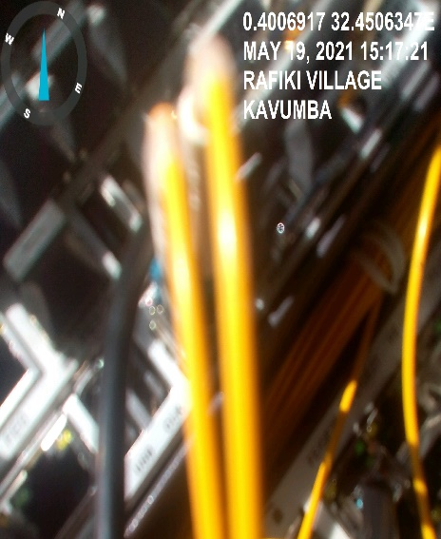
RAFIKI VILLAGE SITE IDU

