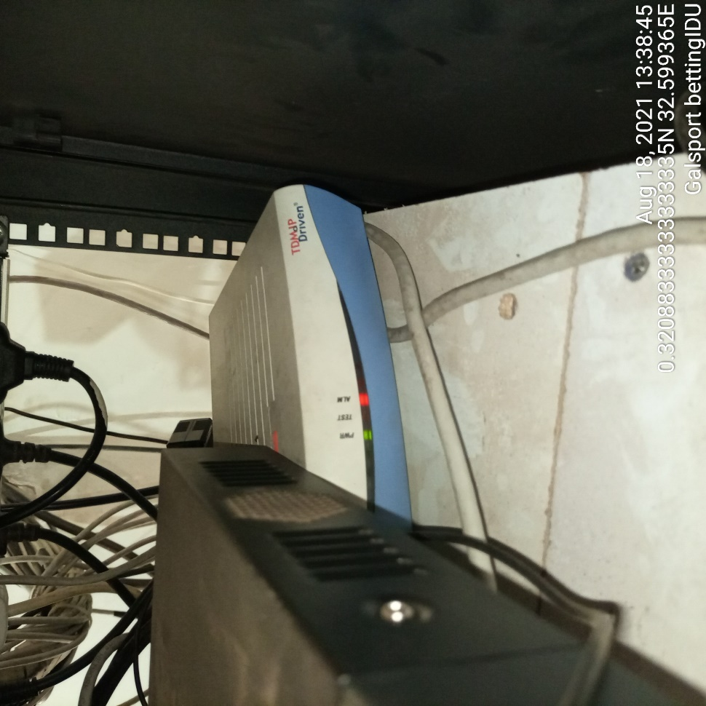
GALSPORTS HQ BETTING IDU

