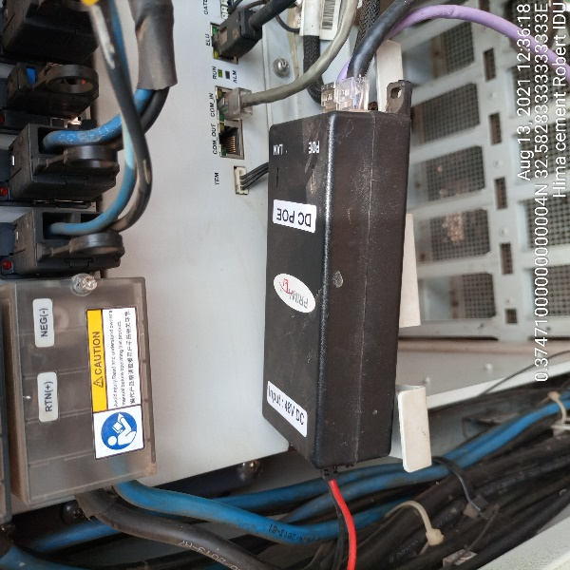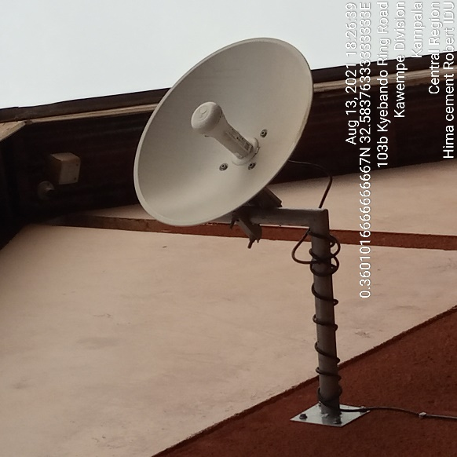
HIMA CEMENT ROBERT IDU HIMA CEMENT ROBERTODU

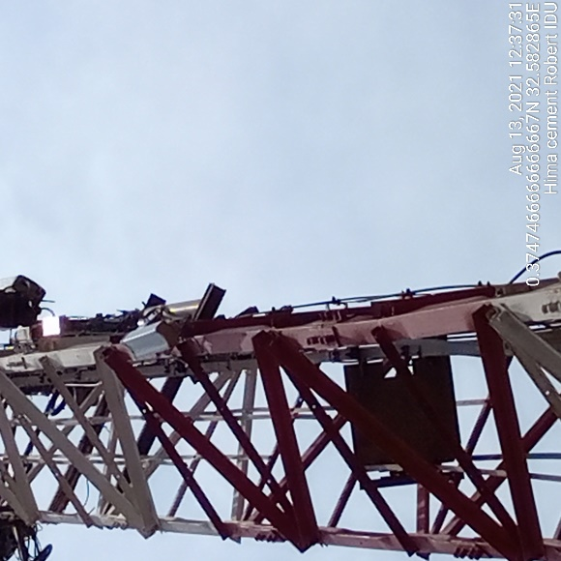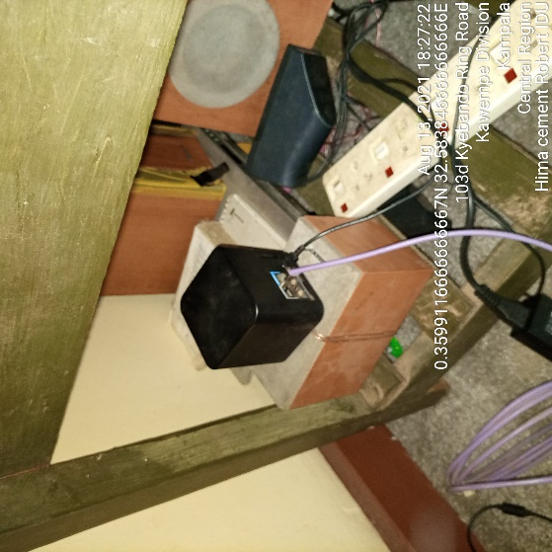
HIMA CEMENT ROBERT ODU HIMA CEMENT ROBERT IDU

