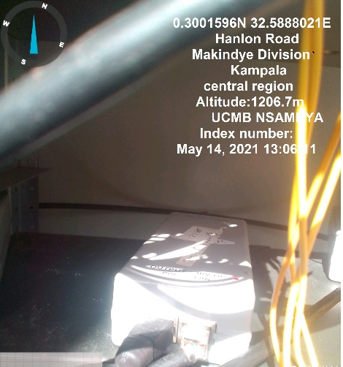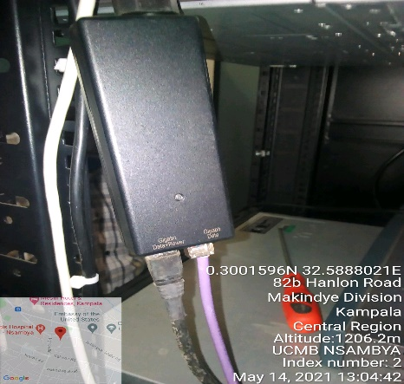
UGANDA CATHOLIC BUREAU SITE IDU UGANDA CATHOLIC BUREAU IDU
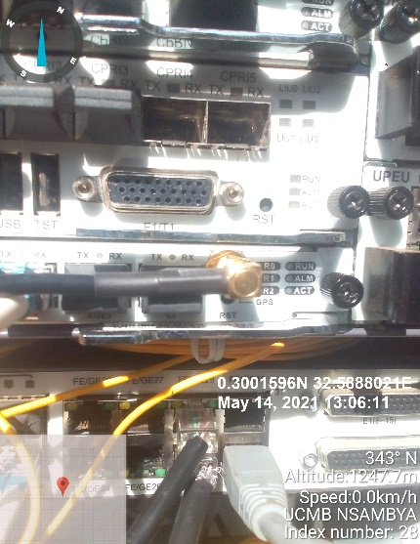
UGANDA CATHOLIC BUREAU SITE IDU

