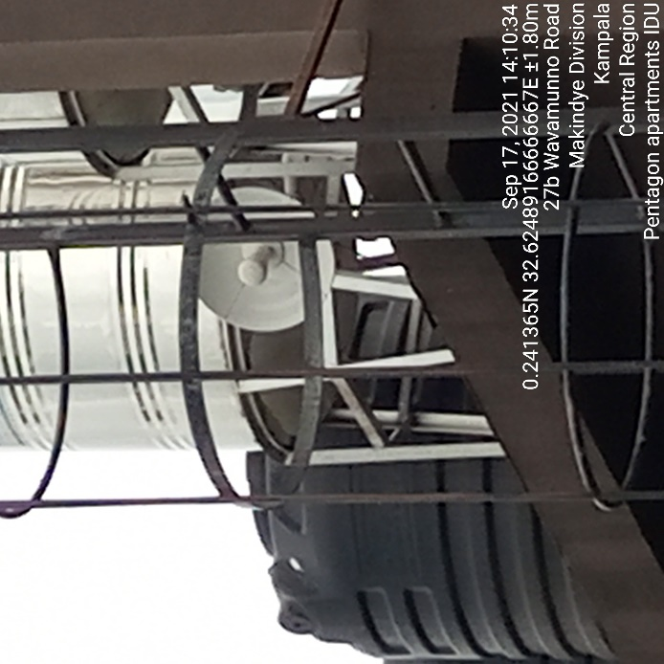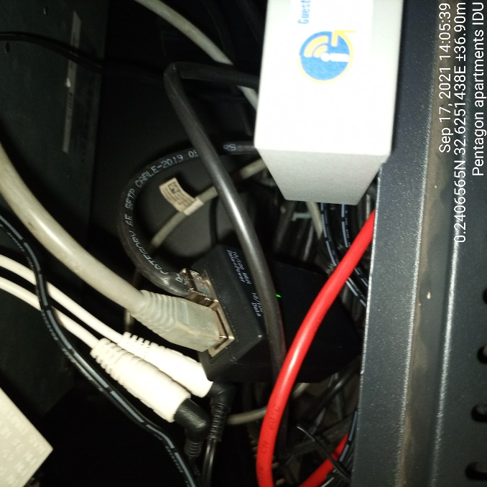
PENTAGON APARTMENTS ODU PENTAGON APARTMENTS IDU

