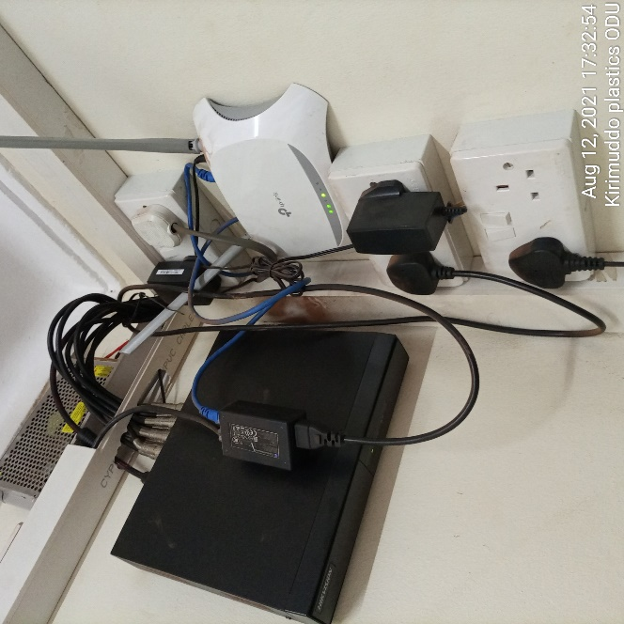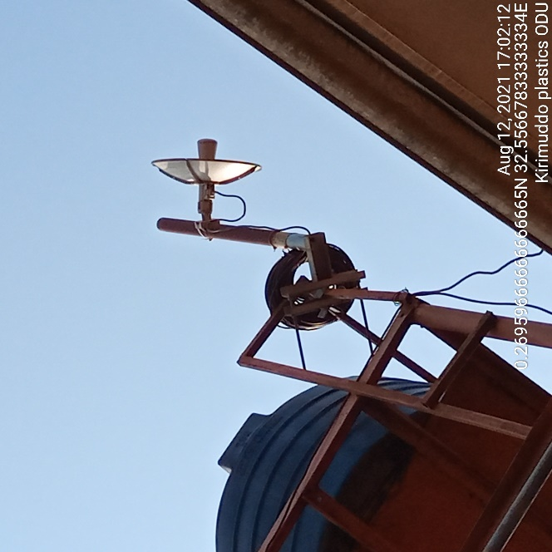
KIRIMUDDO PLASTICS KIRIMUDDO PLASTICS

