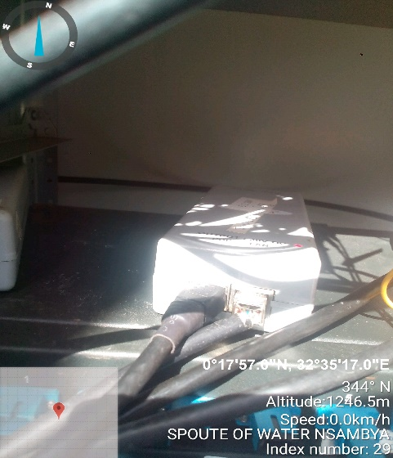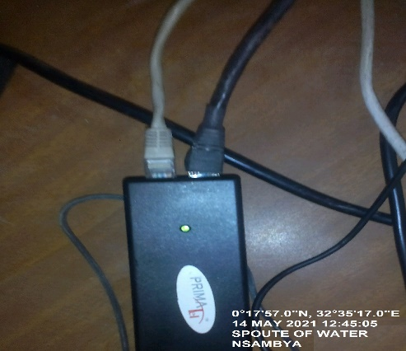
SPOUTE OF WATER SITE IDU SPOUTE OF WATER IDU
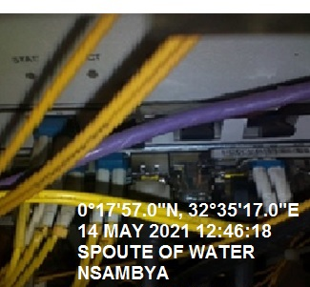
SPOUTE OF WATER SITE IDU

