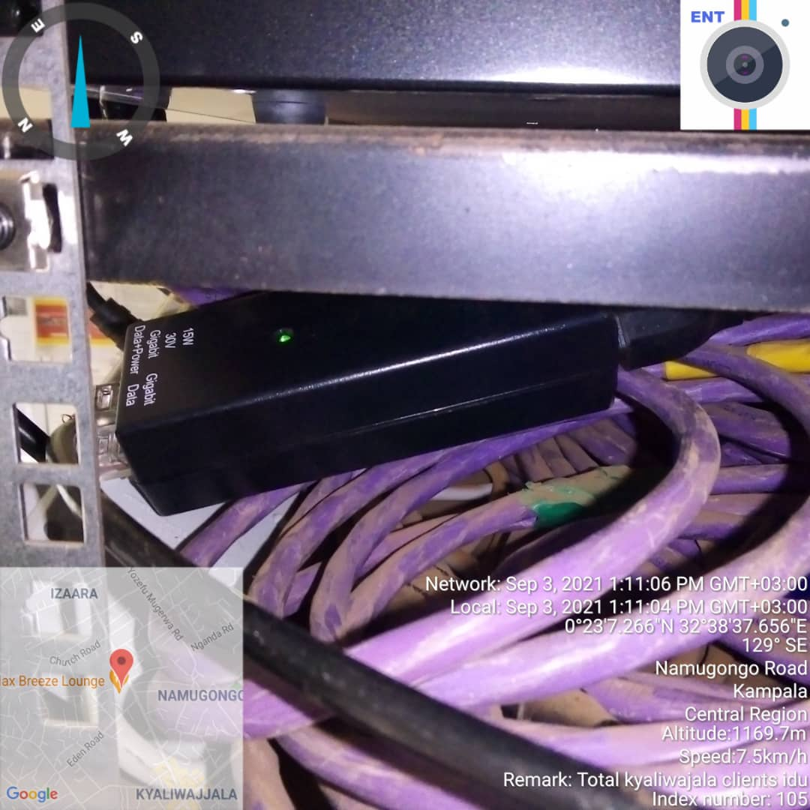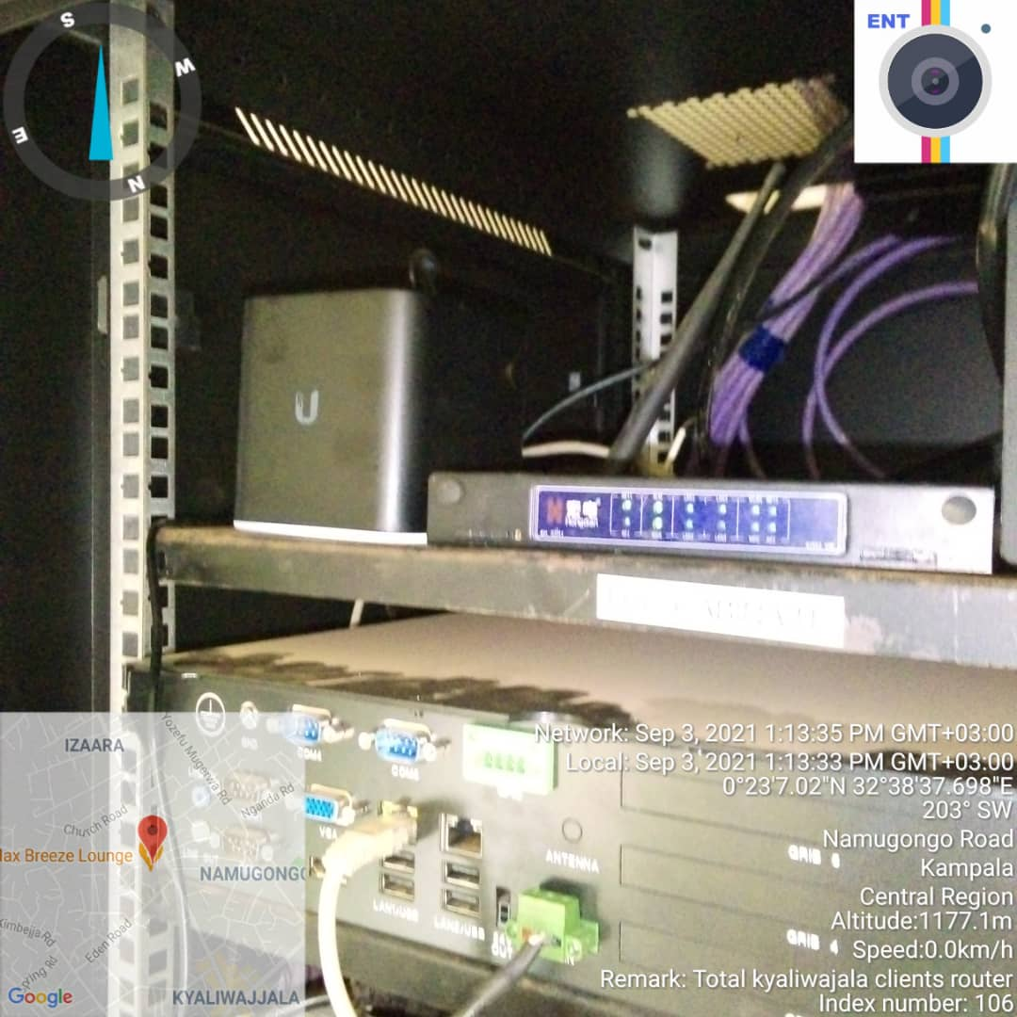
TOTAL KYALIWAJALA IDU TOTAL KYALIWAJALA IDU

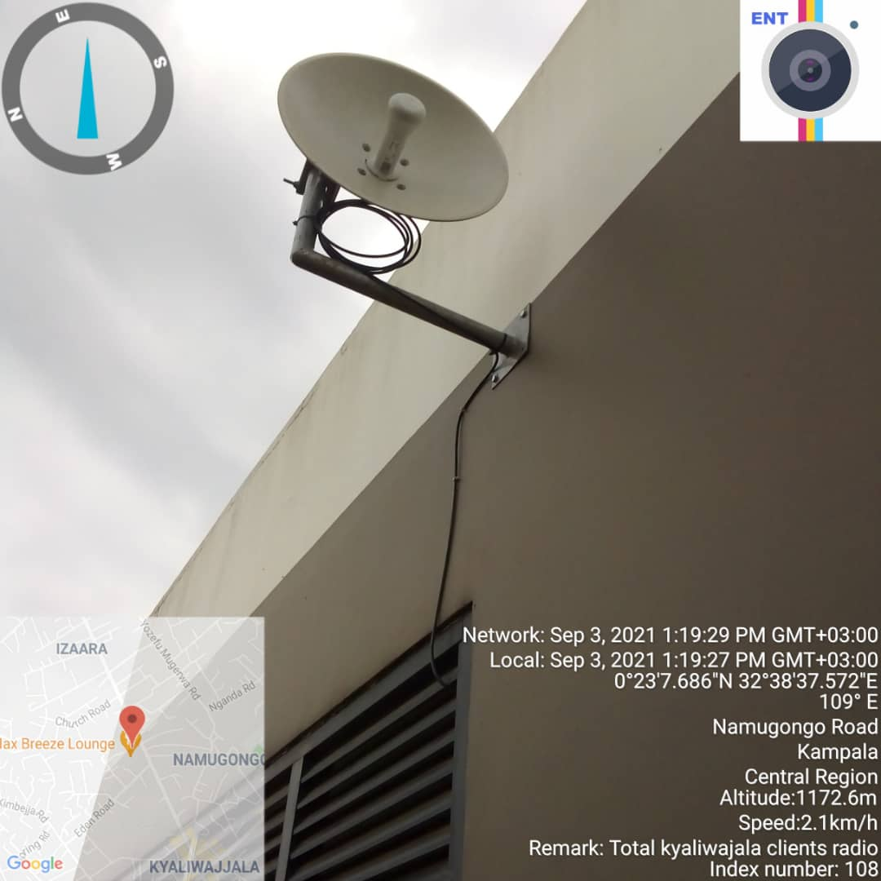
TOTAL KYALIWAJALA ODU

