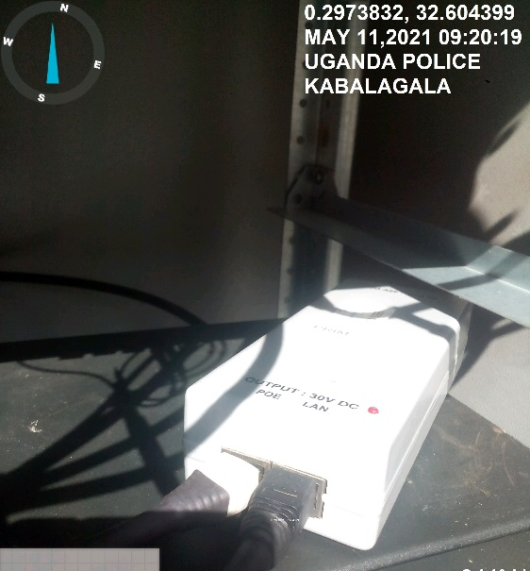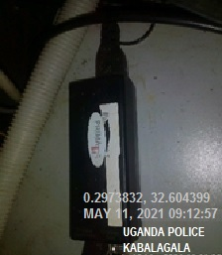
POLICE KABALAGALA SITE IDU POLICE KABALAGALA IDU
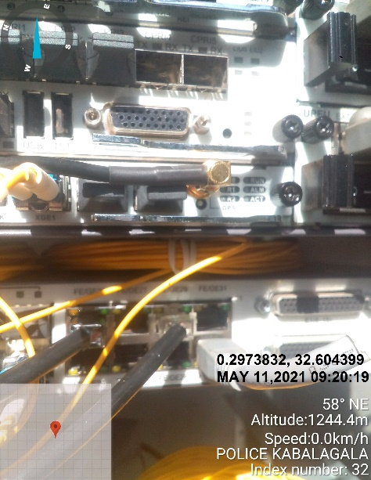
POLICE KABALAGALA SITE IDU

