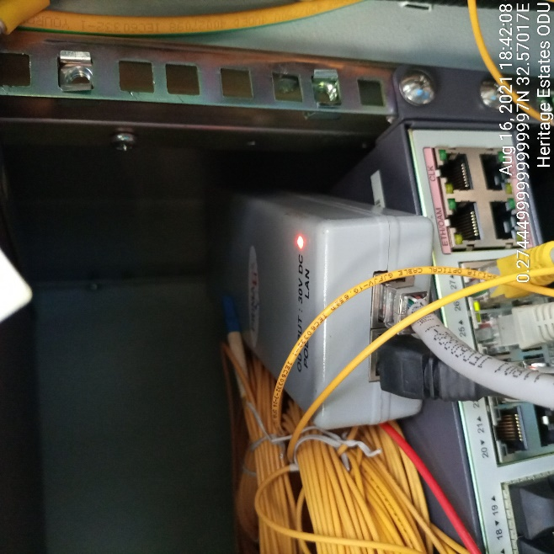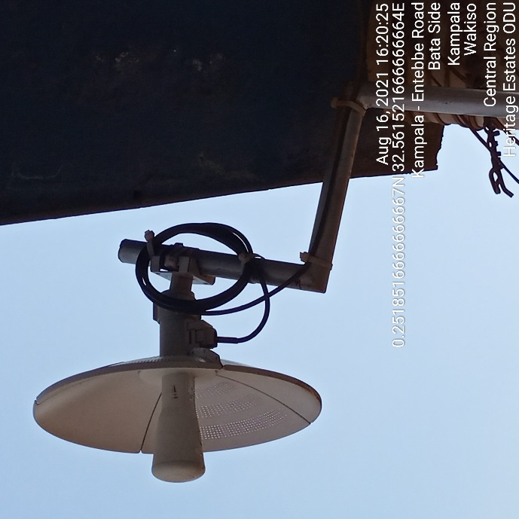

HERITAGE ESTATES IDU HERITAGE ESTATES ODU
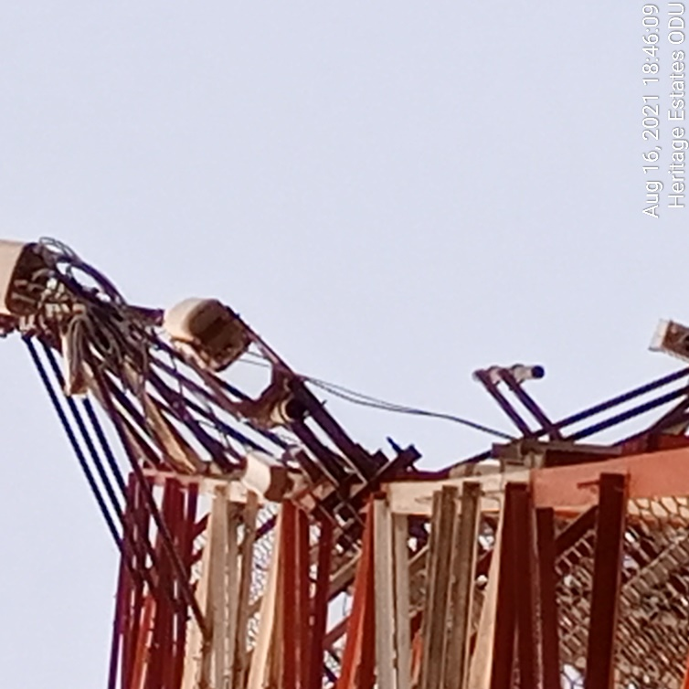
HERITAGE ESTATES ODU

