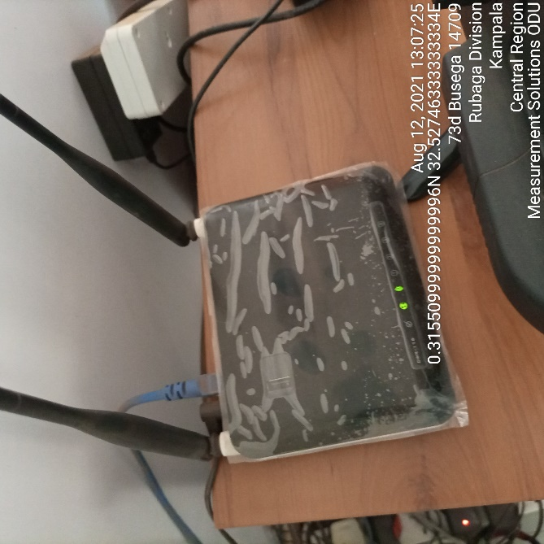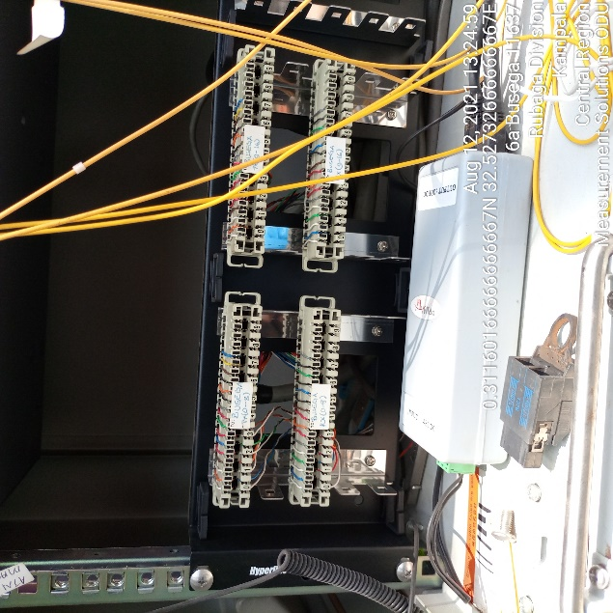
MEAUREMENT SOLUTIONS IDU MEAUREMENT SOLUTIONS IDU
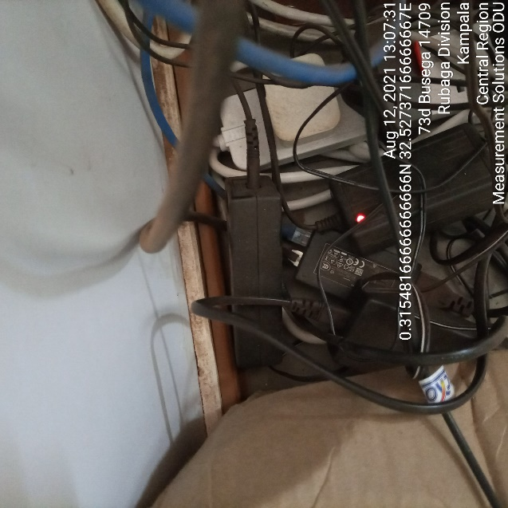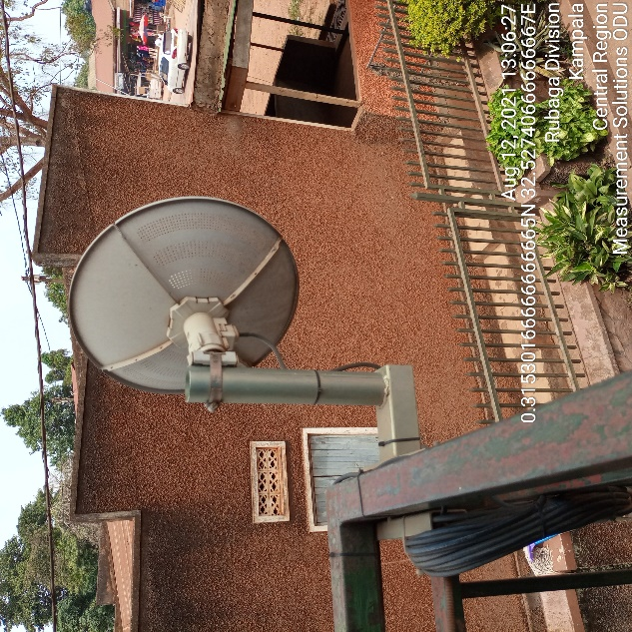
MEASUREMENT SOLUTION IDU MEASUREMENT SOLUTION ODU
