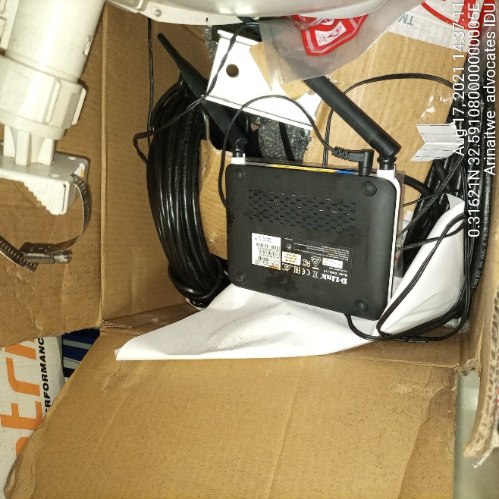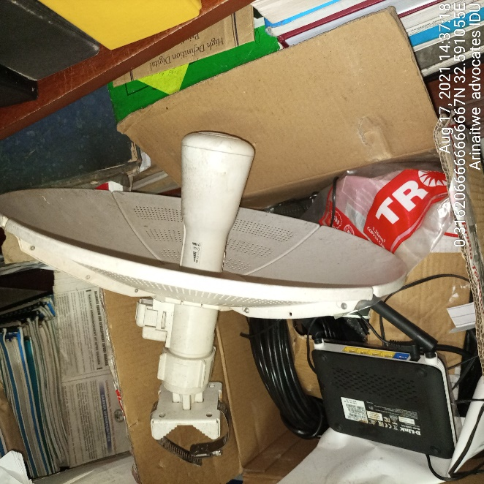
ARINAITWE ADVOCATES DECOMMISIONED ARINAITWE ADVOCATED DECOMMISIONED

