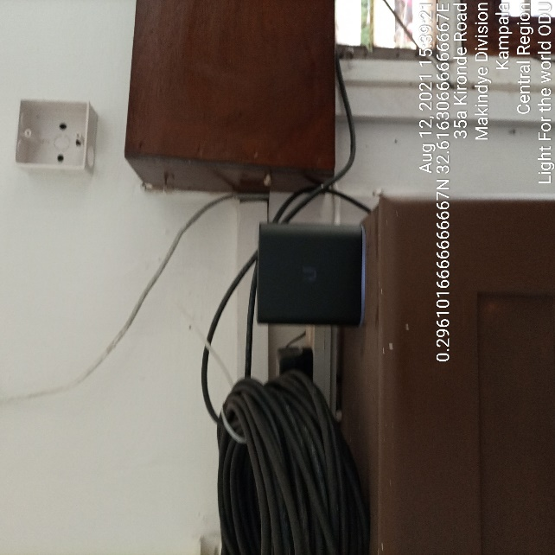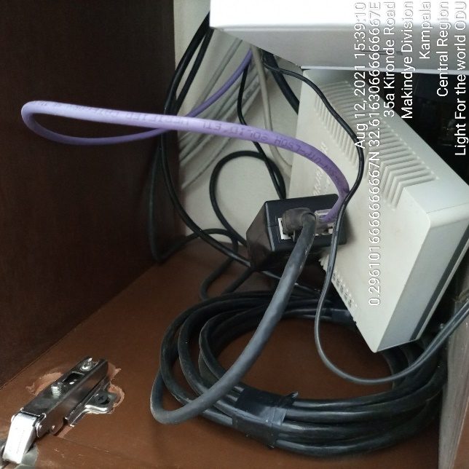
LIGHT FOR THE WORLD IDU LIGHT FOR THE WORLD IDU
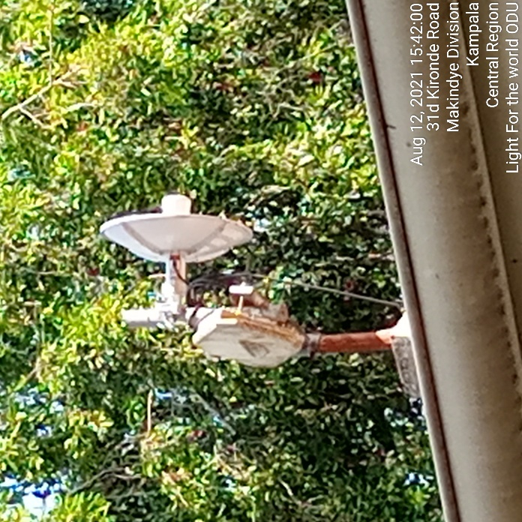
LIGHT FOR THE WORLD ODU

