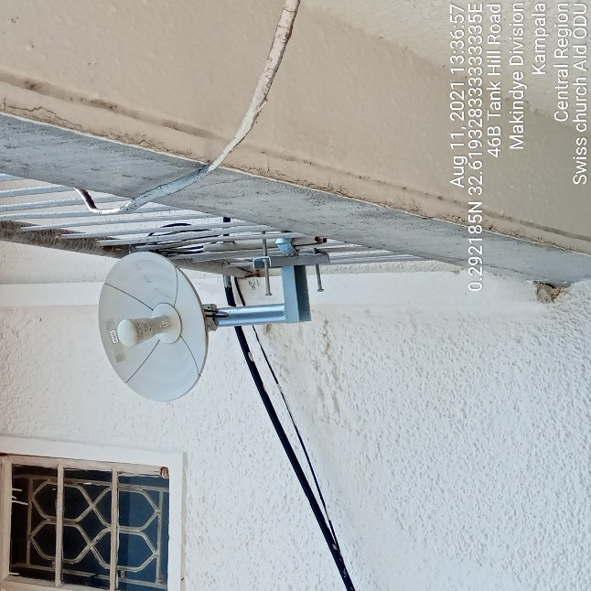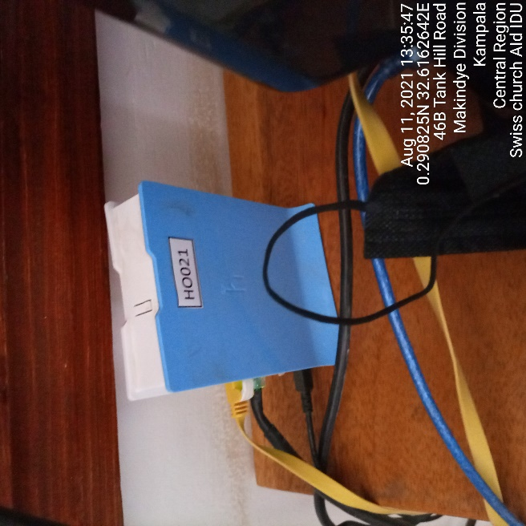
SWISS CHURCH AID ODU SWISS CHURCH AID IDU
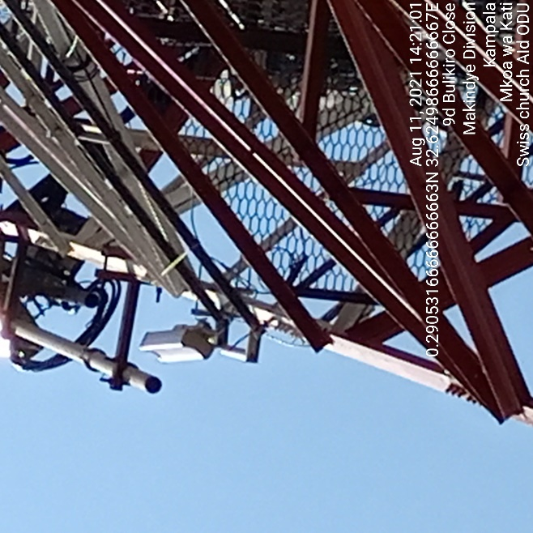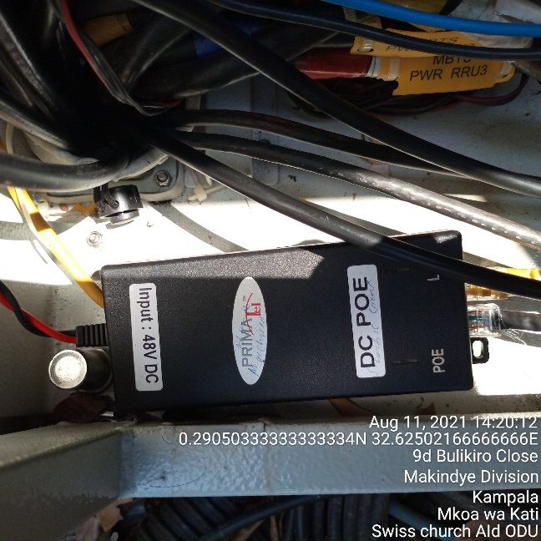
SWISS CHURCH AID ODU SWISS CHURCH AID 1DU

