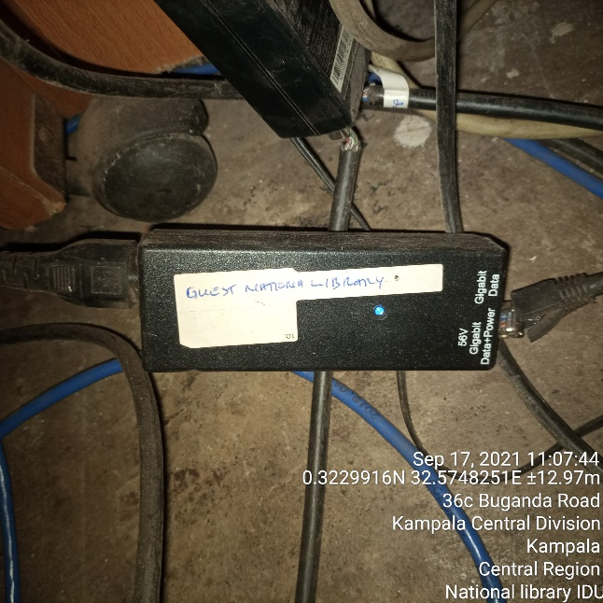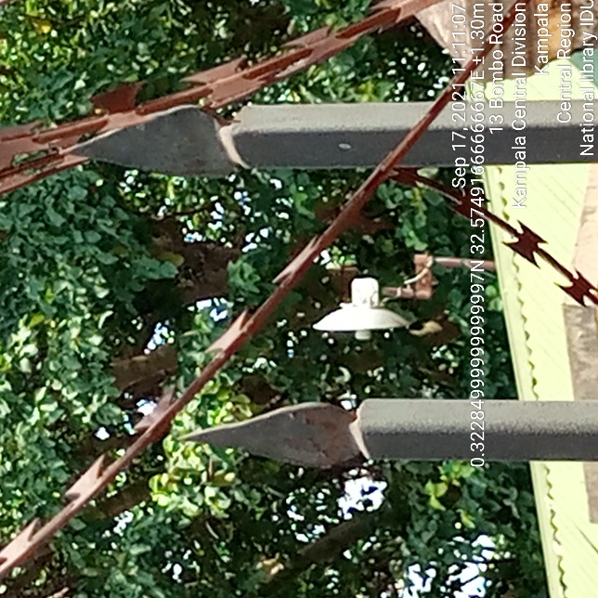
NATIONAL LIBRARY IDU NATIONAL LIBRARY ODU

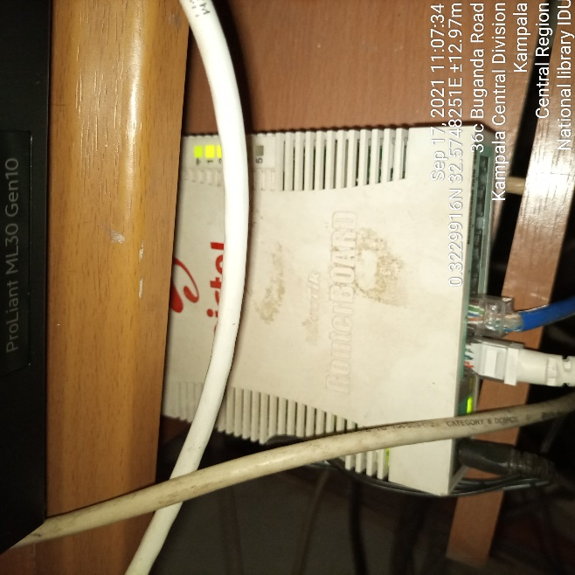
NATIONAL LIBRARY IDU

